ENGINEER 1C03 – Engineering Design & Graphics

McMaster Engineering 1 Design Project

Instructor: Dr. Doyle

**Milestone 1**

Team #4

Lab Section: L01

|  |  |  |
| --- | --- | --- |
| Julien Bordas | 400163815 | bordasj@mcmaster.ca |
| Neng Zhao | 400139605 | zhaon13@mcmaster.ca |
| Martha Nameth | 400148393 | namethm@mcmaster.ca |

# Study of existing hand prosthesis

Hand prosthesis is an advanced artificial hand which help patients who have lost their hand. This device requires patients to have a functional wrist and enough palm to push against the device, to force the fingers to close when the wrist is bent.

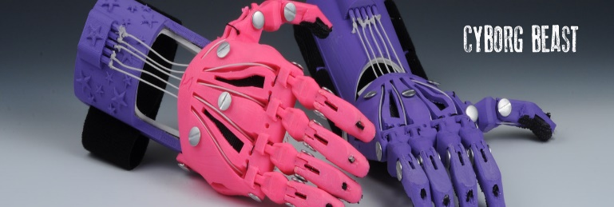An example of the design is the Cyborg Beast (<http://enablingthefuture.org/upper-limb-prosthetics/>), designed by Jorge Zuniga and his team at Creighton University. It uses the strings inserted in the outfit to control the movement of the hand.

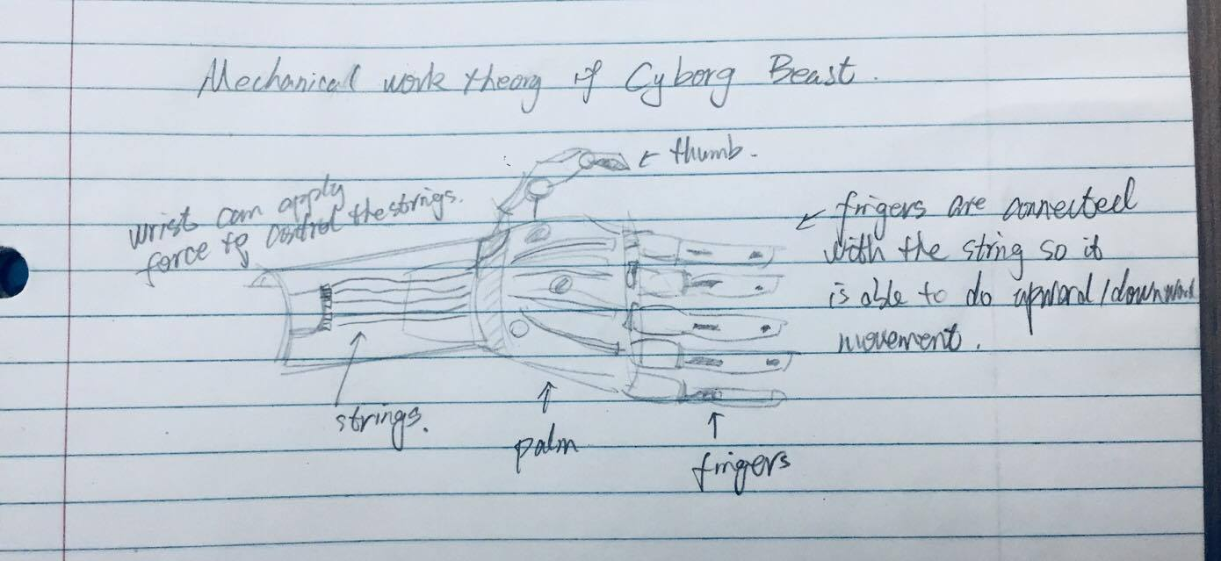As the patient applies force from wrist and palm, he/she can grip objects like using a human hand. To improve the friction, the designer chooses to apply textured fingertips to prevent object from slipping off.

# Our design proposal

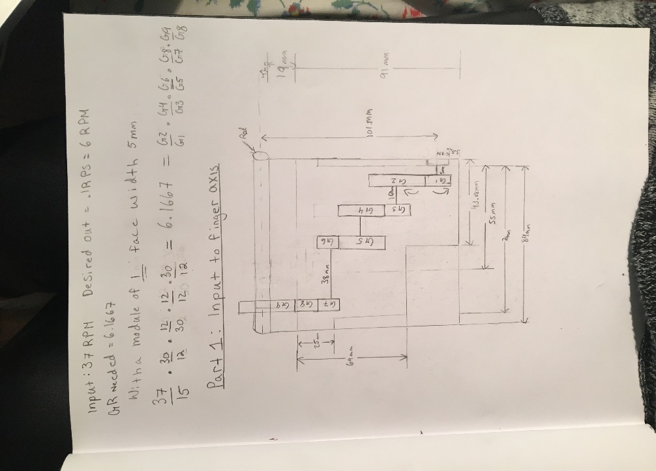Our design rethinks the whole prosthesis mechanism, replacing the strings with gears.

Our mechanism has an input of **37 RPM** and must have an output of **6 RPM**. This gives an overall ratio of $GR=\frac{37}{6}=6.166…7$

We chose to use compound gear trains, to obtain the desired ratio. Hence, we designed a 4-level gear train, giving us the following ratio: $GR=\frac{37}{6}=\frac{37}{15}*\frac{30}{12}*\frac{12}{30}*\frac{30}{12}$

We decided to design two different gear trains, one from the motor to the forefingers – with a ratio of $\frac{37}{6}$– and one from the forefingers to the thumb – with a ratio of 1 and an even number of gears (to generate an opposite rotation).

The fingers will be printed directly on the gears to save space.

We also took into consideration the dimension constraint of the frame and our gears diameters do not exceed these dimensions.

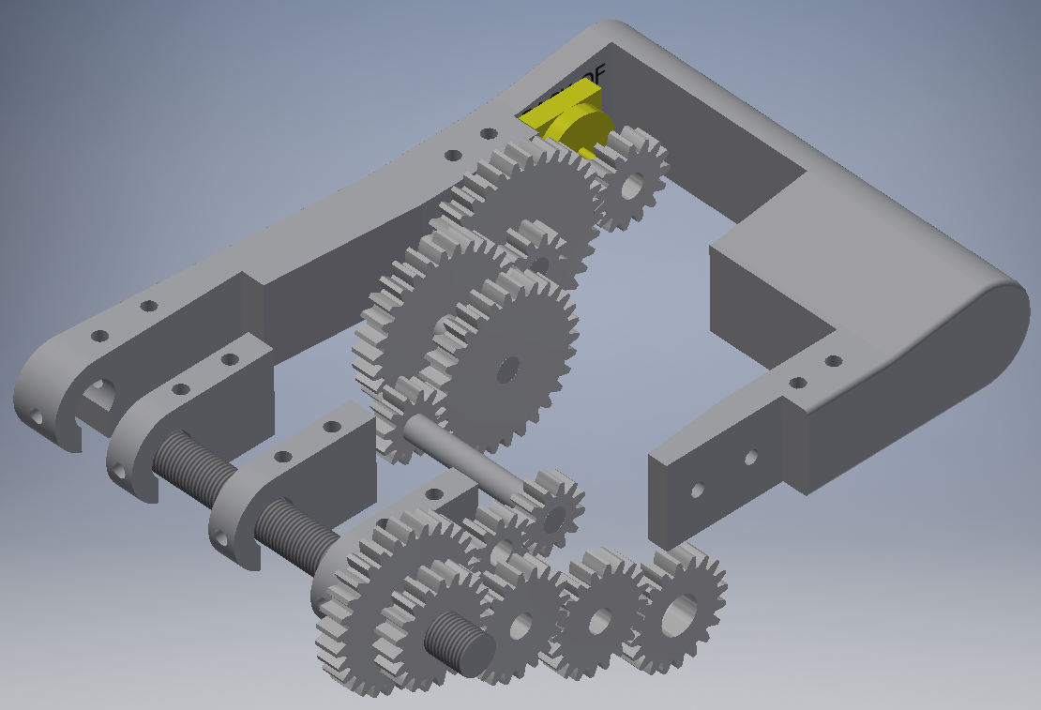We thought of gears with threaded hole in the middle for the forefinger and thumb axis, so that, once they are fixed and hold in place with nuts, they could make the axis rotate.

# Team meetings

Contact Information :

* Julien Bordas (+33) 0620170514 [bordasj@mcmaster.ca](mailto:bordasj@mcmaster.ca)
* Neng Zhao (+1)6476764324 [zhaon13@mcmaster.ca](mailto:zhaon13@mcmaster.ca)
* Martha Nameth (+1)6394713502 [namethm@mcmaster.ca](mailto:namethm@mcmaster.ca)

Meeting Goals :

* Prepare and improve the design
* Agree on the important decisions
* Work on the milestones together

Meetings Schedule

Our meetings are scheduled during the week, at least twice a week, and on Saturday if necessary. Every group members agreed on this organization and schedule.